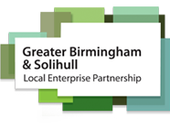

Introduction
The Intelligent Transport Systems World Congress is the leading event in the field of intelligent mobility and is held annually, rotating between Europe, Asia/Pacific, and the Americas.
The West Midlands region are bidding for the event in 2027. This will highlight the transformation the West Midlands has undergone including the successful Coventry of City Culture and Commonwealth Games. Our region includes our new Sprint bus rapid transit system, Midland Metro extensions, 5G, Connected and autonomous vehicles and the first Future Mobility Zone in the UK. It is also an excellent opportunity to promote the UK.
The Birmingham bid represents a once in a generation opportunity to return the event to the UK, as it was last held in London in 2006. We have extensive support from the NEC Group as host venue and from the Department for Transport and Industry bodies ITS UK as well as local support from the West Midlands Combined Authority, Local Councils and West Midlands Growth Company.
We believe that we have a strong chance to secure the World Congress, due to the excellent ITS and future mobility work being undertaken here in the West Midlands and more widely in the UK. It is important that visitors have a stress-free experience that delights them and is memorable in a positive way. We can achieve this by hosting the Congress at the world class venue of the NEC and nearby Resorts World.
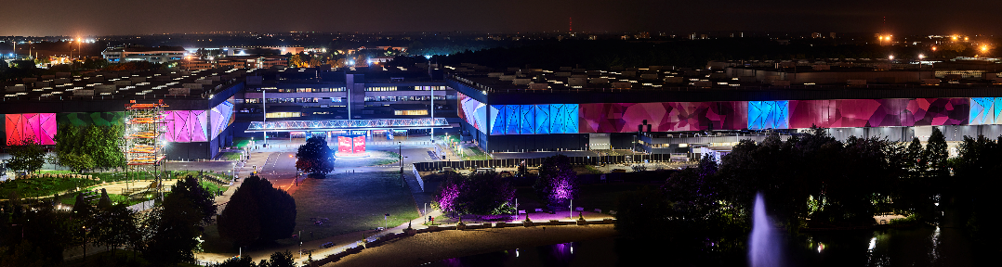
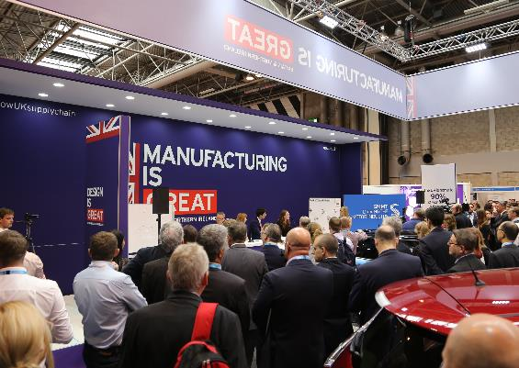
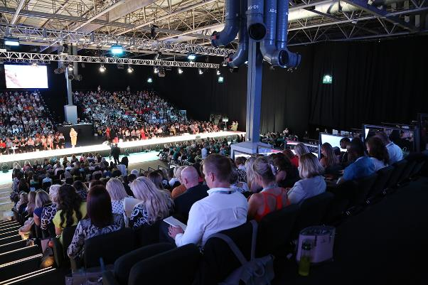
Vital to the success of our bid is showing that we have sufficient support within the Industry in the UK along with commitment to sponsor to show we have the financial backing to make the event a success and a true reflection of the excellent work being carried out in the UK.

Overview of the Birmingham Event
We are still developing the theme for the Congress; our working title is “Future transport, made real” with a programme that balances insight on how to best use existing technologies against practical experience and policies.

The event will be world leading including:
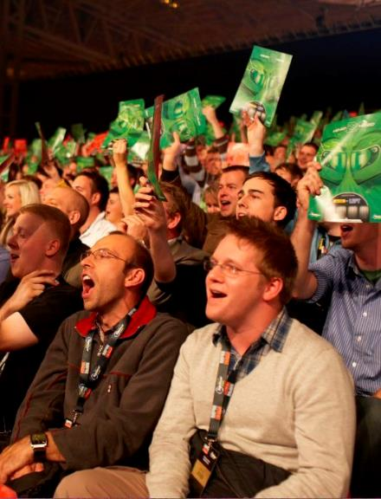
- 15,000+ global leaders from 150 countries including technology providers, consultants, contractors, local and national governments and industry associations
- Five day conference
- 35,000m²+ exhibition including start-up packages
- Potential for indoor vehicle demonstration area of 25,000m² based on sponsorship
- 20+ technical tours of key technology developments in the region including National Highways Control Centre, WMG at University of Warwick, Jaguar Land Rover and Horiba MIRA
- Opportunities for outdoor vehicle and technology demonstrations around NEC / Birmingham Airport / Resorts World Campus including connected and autonomous vehicles
- Gala dinner attracting 700 delegates
- VIP dinner with over 200 senior leaders from the ITS industry
- Young professional development forum
- Fringe events from ITS Associations, solution providers and local / national government
- 5G connectivity
- A commercial focus for the event to encourage commercial opportunities and foster relationships at the event supported by UK Department of International Trade and Innovate UK

Support and Sponsorship
Once we are the confirmed host for the World Congress, we will develop sponsorship packages in conjunction with ERTICO. These will cover a range of sponsorship values and opportunities to promote your brand and derive commercial value, target key customers and build relationships.
At this stage, we are looking for organisations to commit a level of sponsorship. Those that do commit early will have a golden opportunity to shape a package to their needs. We anticipate four sponsorship opportunities:

Sponsor benefits for all packages include:

- Logo at Opening Ceremony
- Logo at Closing Ceremony
- Gala Dinner / VIP Dinner: logo
- Logo on media during event / sessions
- Company profile in programme
- VIP Lounge passes
- VIP Dinner invitations
- Gala Dinner invitations
- First option to organise a demonstration or technical tour at approved locations
- Demonstration discount
- Logo in post congress report sent to all attendees
- ITS World Congress website branded with logo
- Congress App – Listed in Sponsor Section
- Registration area branded with logo and/or other marketing material
- Company logo included in the Exhibition Guide
- Social media promotion by ITS UK, media partners (and international partners) on Twitter and LinkedIn
- Digital promotion leading up to the congress via Newspapers, and ITS UK Newsletters

Key sponsors would be invited to present and exhibit at events we organise to promote the Birmingham Congress in the run up to 2027. Sponsorships packages are subject to confirmation once the Congress is awarded. There will also be opportunities for bespoke sponsorship of individual items such as VIP cars and shuttles. As well as financial commitments to sponsor, we are welcome discussion on provision of in-kind contributions that minimise our costs, such as provision of shuttle services, 5G/ Wii, provision of staff resources, supporting indoor demonstration area.

Deadline for submission of the bid is 14th November 2022 and we would need commitment of support in writing for the end of October 2022.

To pledge your support and to discuss sponsorship opportunities
Contacts | Chris Lane  Head of Transport Innovation  Chris.lane@tfwm.org.uk  +44 (0)121 214 7022  +44 (0)7901 513152  Katie Miller-Crolla  Project Administrator- Innovation Projects Team  Katie.Miller-Crolla@tfwm.org.uk  +44 (0)121 214 7828

Appendix 1: Indicative Sponsorship Packages
 | Bronze | Silver | Gold | Platinum
Logo at Opening Ceremony | X | X | X | X
Logo at Closing Ceremony | X | X | X | X
Discounts at demonstration
Speaking Slot – Plenary session |  |  |  | X
Speaking Slot – Executive session |  |  | X | X
Gala Dinner / VIP Dinner: logo | X | X | X | X
Partner of the ITS Summit |  |  |  | X
Partner of the VIP Dinner |  |  |  | X
Partner of the ITS Summit |  |  |  | X
Logo on media during event / sessions | X | X | X | X
Logo on congress bags |  |  | X | X
Delegate bag inserts |  |  | X | X
Company profile in programme | X | X | X | X
Advertisement in programme |  | Half page | Full page | Double page
VIP Lounge passes | 2 | 2 | 4 | 6
VIP Dinner invitations | 1 | 2 | 3 | 4
Gala Dinner invitations | 1 | 2 | 3 | 4
Free delegate registrations | 1 | 2 | 3 | 4
Access to dedicated meeting room |  |  |  | X
First option to organise a demonstration or technical tour at approved locations |  |  | X | X
10% Exhibition discount |  | <9m² | <18m² | <36m²
20% Demonstration discount | X | X | X | X
Testimonial video on official website |  |  | X | X
Logo in post congress report sent to all attendees | X | X | X | X
ITS World Congress website branded with logo | X | X | X | X
Congress App – Listed in Sponsor Section | X | X | X | X
Registration area branded with logo and/or other marketing material | X | X | X | X
Company logo included in the Exhibition Guide | X | X | X | X
Social media promotion by ITS UK, media partners (and international partners) on Twitter and LinkedIn | X | X | X | X
Digital promotion leading up to the congress via Newspapers, and ITS UK Newsletters | X | X | X | X

